

CHANGZHOU TRUE POWER MACHINERY CO.,LTD

NO508,YULONG NORTH RD, XINBEI DISTRICT CHANGZHOU ,JIANGSU,CHINA TEL: 0086 18262549930 FAX: 0086-519-85800702 Web: www.china-tricycle.com

Sightseeing Tricycle
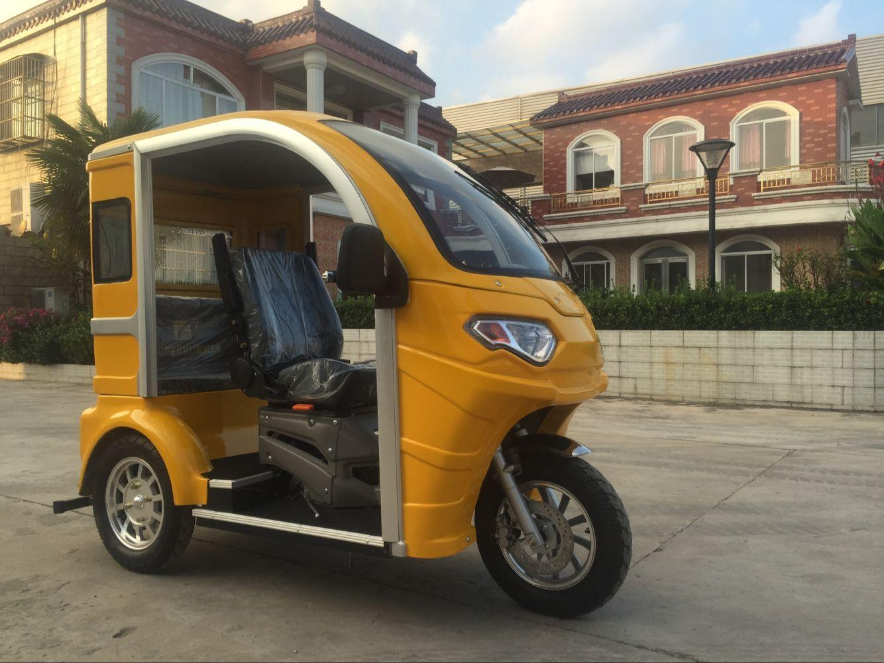
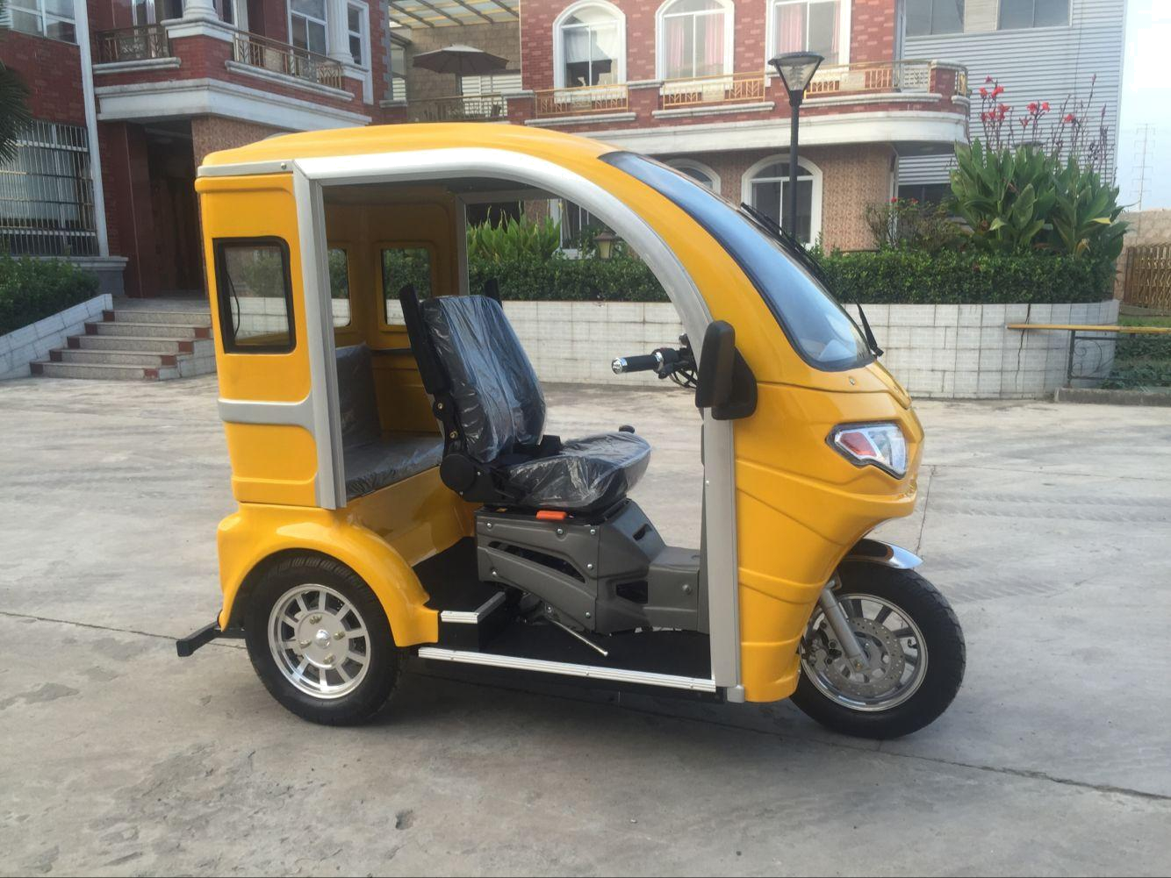

MODEL NO :DTR-15

SPECITIFICATION

Engine | Type | One cylinder,4 stoke,air cooling/automatic gear
 | Dispacement | 110cc/125cc
 | Starting method | Electric /Hand
Performance parameter | Fuel tank capacity | 5L
 | Brake front/rear | Disc/disc
 | Max speed | 45-60km/h
 | Max loading | 150-200kg
 | Oil consumption | 2.5(L/100km)
 | Transmission mode | shaft
 | Wheel (Front/Rear) | 400-12 Tubeless
 | Wheel base | 1350mm
 | Track | 690mm
Weight | Net weight | 169kg
Total size | 2140*900*1640mm(L*W*H)
Loading Qty | SKD30units
Color | Blue/red/white/yellow/other

